LAB 6

Note: Don’t take the values of arrays from the user. Assign them in the code.

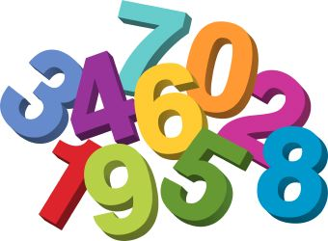
1- Write a program that prints the odd numbers in the existing array.

Example:
int[] numbers = {3, 4, 7, 3, 2, 1, 4, 5, 9, 6, 4, 12};

Output: 3 7 3 1 5 9

2- Assume that we declared the following two arrays.


names = {ali, emine, fatma, sibel, zeynep}
tel_numbers = {4234411, 2216688, 3348845, 2225543, 2243321}

Write a program that prints the telephone number whose given name.

Example:
Inputs: emine
Output: 2216688

Inputs: fatma
Output: 3348845

3- Write a program that prints the median of number(s) in the array.

Example:
Dim array() As Integer = { 3, 4, 6, 7, 8, 12, 18, 20, 22, 26 }

Output: 10 (since (8 + 12) / 2)

Example:
Dim array() As Integer = { 3, 4, 6, 7, 8, 12, 18, 20, 22}

Output: 8

4- Write a program that determines whether the array is constant, or not.

Examples:
Dim array() As Integer = { 6, 6, 6, 6, 6, 6 }
Output: constant

Dim array() As Integer = { 6, 6, 4, 6, 3, 6 }
Output: not constant


5- Write a program that finds “how many the smallest numbers are there”.

Example:
int[] arr = { 6, 8, 3, 4, 3, 16, 30, 3, 3, 12 };

Output: 4

6- Write a program that exchanges “Izmir” values with “Istanbul” and “Istanbul” values with “Izmir” in the same array.

string[] array = new string[] {"Ankara", "Izmir", "Izmir", "Antalya", "Izmir", "Trabzon", "Istanbul", "Bursa", "Aydın", "Istanbul"};

Output array:
{"Ankara", "Istanbul", "Istanbul", "Antalya", "Istanbul", "Trabzon", "Izmir", "Bursa", "Aydın", "Izmir"};

7- Write a program that writes the histogram of the array.

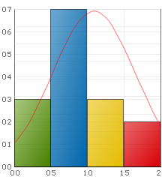
Example:
int[] arr = {35, 51, 59, 0, 5, 100, 9, 10, 15, 19, 50, 55, 89, 99}

Output:
0 - 19: ******
20 - 39: *
40 - 59: ****
60 - 79:
80 - 100: ***

8- Write a program that converts a given decimal number (between 0 and 255) to binary system.

Example:

Input : 45
Output: 00101101

Input : 60
Output: 00111100

static void Main(string[] args)
{
int number;
int[] binary = { 0, 0, 0, 0, 0, 0, 0, 0 };
...
}

9- Write a program that shifts the elements of an array by one.

Example:
int[] arr = { 1, 2, 3, 4, 5, 6, 7, 8 };

Output:
arr = { 2, 3, 4, 5, 6, 7, 8, 1 }

10- Write a program that prints the intersection of two arrays: arr1 and arr2.
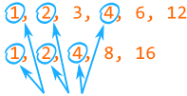
Examples:
int[] arr1 = { 1, 2, 3, 4, 6, 12 };
int[] arr2 = { 2, 1, 8, 4, 16 };
Output: 1 2 4

